SOFT CONTACT LENSES
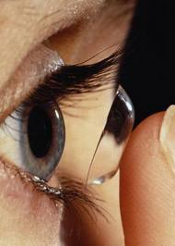

RECOMMENDED FOR ANYONE 13 YEARS OF AGE OR OLDER

Contact lenses are ideal for school, at work, sports and outdoor activities.
They provide better vision; Dr. Gupta explains how to insert and remove them and take care of them so they are safe to use. She also recommends glasses to decrease overuse of contact lenses, and recommends restricting their use for 8-10 hours a day.

Younger Adults:
Spherical or colored
Toric (correct Astigmatism)
Adults>40 years old:
Monovision or Bifocal
Spherical or colored
Toric (correct Astigmatism)

They are cosmetic, so are not covered by Insurances, fitting charge is between $100-$130. Special contact lenses could be ordered and fitted too.
You have to order the contact lenses boxes separately.

Fitting Class Includes:
Pair of Contact which is good for one month, Case is provided, and they can be ordered from the optical shop for 1 month, 3 months, 6 months or a year’s supply. Cleaning solution can be bought upfront for your convenience.

