Macular Degeneration
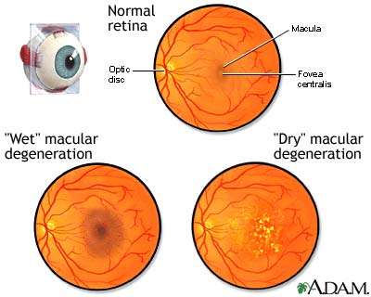

Age-related macular degeneration is the second highest cause of irreversible blindness in the world. Macular degeneration is a leading cause of vision loss in Americans 60 years of age and older. Destruction of the macula (the central area of the retina), leads to loss of the sharp, fine-detail, “straight ahead” vision required for activities like reading, driving, recognizing faces, and seeing the world in color. A person may see a smudge or a gray or black spot as they look straight ahead. Side vision or peripheral vision is not affected.
Dr Gupta monitors and documents your macula with a fundus photo and refers you to a retina specialist if it is Wet type or advanced dry type. It is treated with injections OR Laser OR a telescopic lens implant.
For Dry ARMD, Dr Gupta recommends ICaps: Vitamin A (Beta Carotene), Vitamin C and E, Zinc and Copper, Lutein and Zeaxanthine according to AREDS research which helps to slow the progression. She also recommends to incorporate dietary antioxidants like: spinach, collard greens, kale, Omega 3 fatty acid supplements, wear sunglasses to protect eyes from UV rays, stop smoking, and control Blood pressure. She also gives an Amsler grid to monitor any progression, by yourself at home.

