FLOATERS

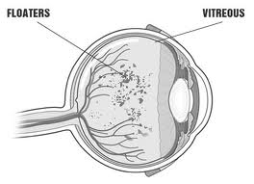

Eye floaters are spots in your vision. Eye floaters may look like black or gray specks, strings or cobwebs that drift about when you move your eyes.
Most eye floaters are caused by age-related changes that occur as the jelly-like substance (vitreous) inside your eyes becomes more liquid. When this happens, microscopic fibers within the vitreous tend to clump together and can cast tiny shadows on your retina, which you may see as eye floaters.
If you notice a sudden increase in the number of eye floaters, contact an eye specialist immediately - especially if you also see flashes of light or loose your peripheral vision. These can be symptoms of an emergency that requires prompt attention.
Dr Gupta dilates your eyes, checks to see, if these floaters are of no consequence or if there is a tear, hole, weakness or detachment of the retina, she promptly refers you to a retina specialist who could do a laser to seal the tear or hole, if its detected early on, or you may need advanced surgery to repair the detachment.

