CHALAZION
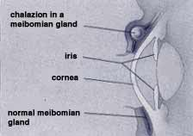
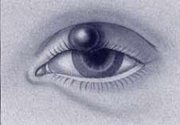

Chalazion is an inflammatory reaction to trapped oil secretion. It is not caused by bacteria, although the site can become infected by bacteria. It can cause the entire eyelid to swell or be focal or localize, like a ball.

Symptoms:
Eyelid tenderness; or no pain at all, Increased tearing; swelling of the eyelid. They could last for a few days, to months or years. Cleaning eyelids routinely with baby shampoo helps if you get them frequently.

Treatment:
Apply dry warm compresses for 5 to 10 minutes, 2-3 times a day. It helps open the blocked pores so that it can drain and start to heal faster.
Antibiotic mixed with steroid eye drops or ointment are usually used several days to decrease the infection and inflammation.
Dr Gupta also prescribes oral antibiotics specific for the eyelids. If the chalazion continues to get bigger, it may need to be removed with surgery. This is usually done from underneath the eyelid to avoid a scar on the skin.
Steroid injection is another treatment option.

