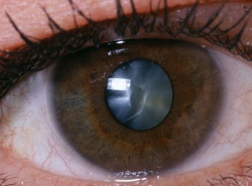
Cataracts

Cataracts are the leading cause of vision loss among adults age 60 or older, they impair vision, making everyday activities like driving at night or reading increasingly difficult.
It is a normal aging process that changes the natural, clear lens of the eye into a cloudy, opaque structure that stops the passage of light to the retina. The condition can be compared to a window that is frosted or "fogged" with steam. Causes include aging, steroids, trauma, Diabetes, smoking or alcohol.
Symptoms include Washed out Color Vision, Glare and Haloes at night, low contrast sensitivity, cloudy, double or blurred vision and poor vision in low lighting.
Dr Gupta can diagnose cataracts by examining the eyes with a slit lamp. She recommends: Don't smoke. Always wear a hat or sunglasses in the sun. Keep diabetes well controlled. Limit alcohol consumption.
If your vision loss can't be corrected with glasses or contacts, she recommends and refers for surgery to remove the cataracts. The cloudy lens is removed and replaced with an artificial lens. The surgery is done on an outpatient basis, is safe and extremely effective at improving vision. On follow up exam, she recommends glasses to ensure maximum Distance and Reading potential is achieved.

