GLAUCOMA
Normal Optic Nerve vs. Enlarged Optic Nerve
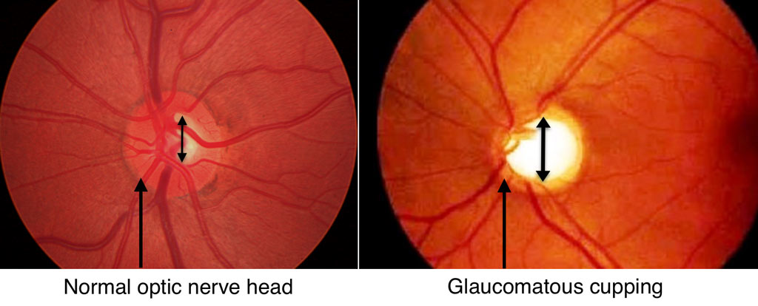
If during today’s visit, Dr Gupta found out that patient’s optic nerve is enlarged, the pressure inside the eye is high or you have a family history of glaucoma, then Fundus photos and gonioscopy is done to document the optic nerve size and check the angle to see if its open or closed. Tests below are done on the next office visit to see if the patient’s enlarged optic nerve has begun to affect their vision.
Normally Glaucoma is a disease of older people.
OCT Testing: A test in which the doctor uses a special laser to take multiple 3-dimensional photographs of the optic nerve to ensure there is no damage to the optic nerve.
Visual Field: A visual field test produces a map of your complete field of vision which is affected if you have Glaucoma. During this test, you will be asked to look straight ahead and then press a buzzer when a moving light passes your peripheral (or side) vision.
Pachymetry: A simple probe placed on the front of the eye to measure the thickness of your cornea. Thicker cornea protects against high pressures in eyes.
Color vision test and Flash plus Photopic negative response ffERG is also documented to ensure there is no loss of vision loss early on.
Dr. Gupta would like base line testing done to ensure that optic nerve is big since birth and adjusted pressures are normal meaning cupping is physiologic and not due to Glaucoma. If Glaucoma is diagnosed, drops are promptly started, follow up is done on a routine basis and in cases of advanced glaucoma, patients are referred to a Glaucoma specialist.

