AMBLYOPIA
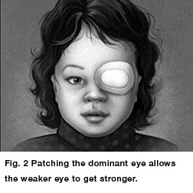

Amblyopia, commonly called lazy eye, is a condition in children when vision does not develop properly in one or both eyes. If it’s left untreated, a child's vision will never develop correctly. Vision impairment becomes permanent because as the child’s brain matures, it will "ignore" the image coming from the poorly seeing eye. That’s why it’s essential to have a child with amblyopia regularly tested by an eye doctor.
Amblyopia occurs in early childhood. When nerve pathways between the brain and an eye aren't properly stimulated, the brain favors the other stronger eye.
The doctor has recommended this exercise for the patient because his/her prescription for glasses is very high. This exercise will make the eye(s) that are not being patched force themselves to see better allowing them to gain more strength and help improve the patient’s vision. This exercise may be done while the patient is doing any type of activity for example while the patient eats, does homework, watches television, plays and etc.
Instructions For Patching Eyes:
The patient’s
Both Eyes Right eye Left Eye
must be patched every day for 2 hours for the next 2 months.
Patient Must patch alternate eyes every day, if both eyes are recommended to be patched.
Example: Monday: Patch Left Eye Tuesday: Patch Right Eye.
It is very important to Use patches with the recommended glasses.

Follow up with Dr Gupta after 2 months to make sure that the lazy eye has improved and/ or whether the patching needs to be continued or not.

